Clip Assistant Product Plan and Architecture
First version for interview producers | Working hypothesis | 11 September 2026
This plan defines a local editing assistant that helps interview producers find promising passages in long recordings, understand why they may work, adjust the cuts, and export a 480p rough cut. The target outcome is less time from recording to an editor-approved clip while preserving the speaker’s meaning. This is an independent audition project, not an official Steven.com product. The workflow remains a hypothesis until an editor tests it.

Product scope
The first version keeps source media on the Mac and uses OpenAI for text analysis only. The browser is the control panel; a small Python server coordinates transcription, analysis, review, and export.
Boundary | First version decision
Media | Source video, extracted audio, and exported clips stay on the Mac.
AI input | Transcript excerpts, timestamps, and analysis instructions go to OpenAI.
Editorial control | The score is an explainable heuristic; a human approves every sequence.
Output | Approved cuts export as a separate 480p MP4; the original remains unchanged.

How the workflow works
local video → local audio → local transcript → OpenAI text analysis → human approval → local 480p clips
Candidate clips default to contiguous 30–90 second ranges and are scored equally on hook clarity, specificity, payoff, audience fit, and standalone coherence. Each criterion receives 0–4 points. The displayed score is the sum multiplied by five, giving a 0–100 scale. It is an editorial heuristic, not a probability or virality prediction. Context review remains separate because transcript analysis cannot verify claims or judge visuals.

The first screen to export journey
- Choose a local video, describe its audience, and set the desired clip length.
- The app extracts small audio chunks and transcribes them on the Mac. Saved checkpoints allow transcription to resume.
- With a locally configured OpenAI key, transcript batches are assessed for candidate clips and context risks. Video and audio are never sent to OpenAI.
- Review candidate passages beside the video and transcript. Inspect scores and risks, then adjust or combine time ranges.
- Preview the sequence, approve it, and export a separate 480p MP4. The original remains unchanged.
Without an API key, clearly labelled local mode provides rough passage windows without AI editorial scores. This supports transcription and rendering tests without implying that AI analysis ran.

Editorial scoring rubric
Criterion | Question
Hook | Does the beginning provide a reason to keep watching?
Specificity | Is there a concrete story, example, or insight?
Payoff | Does it resolve the question or tension it creates?
Audience fit | Why would this project’s audience care?
Coherence | Does it make sense without the rest of the interview?

A score of 80 means 16 out of 20 rubric points, not an 80% chance of success. The score belongs to the original suggestion; changing the cuts does not automatically rescore it. An exciting sentence can still make a poor clip if it loses context or has weak visual delivery, so human review stays essential.

How the first version will be checked
- Run an actual local video through transcription and export; verify timestamps, duration, audio, and 480p dimensions.
- Check multi-passage exports and a recording longer than one transcription chunk.
- Test invalid timestamps, invalid model references, missing API keys, interrupted jobs, and unsafe browser requests.
- Label synthetic calibration material. A synthetic test proves plumbing, not editorial taste.
- Compare top suggestions with an editor’s independent choices on unseen interviews. Measure accepted clips and total review and correction time.

Deliberate limits and current evidence
- Mac-first and English transcription initially; at most one transcription job and one export at a time.
- Audio is transcribed in consecutive five-minute chunks. A sentence crossing a boundary may need correction; the system does not guess new timestamps to merge text.
- No automatic publishing, vertical reframing, captions, or cloud video storage. Original-video browser preview depends on browser codec support.
- A 100 GB file stays on disk, but that size is not a tested guarantee. Duration, codec, and available disk space affect processing.
- A dedicated OpenAI key is configured locally. On 11 September 2026, a 14-minute real video completed three live analysis runs with three final suggestions and one clean 90-second 480p export; two suggestions still needed trimming, and the scores remain uncalibrated editorial ratings.

Delivery order
Working local pipeline → working review screen → bounded AI analysis → end-to-end checks → editor trial. Keep the smallest complete workflow before adding integrations.

Architecture
The browser controls the workflow, while a small Python server on this Mac performs the work. Only transcript text and analysis instructions cross the API boundary. Original video, extracted audio, and exported clips remain local.
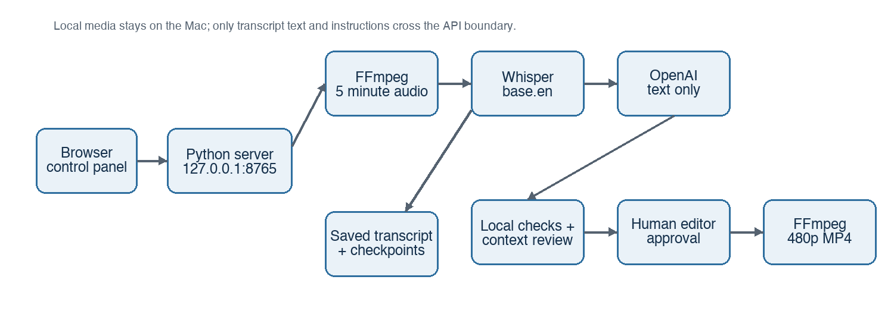
Figure 1. First-version local processing flow

System parts and responsibilities
Part | What it does | Where it runs
Browser interface (web/) | Video playback, transcript, suggestions, editable ranges, and downloads | This Mac
Python server (server.py) | Starts jobs, reports progress, and serves local media | This Mac at 127.0.0.1:8765
Media pipeline (pipeline.py) | Coordinates transcription, analysis, and rendering | This Mac
FFprobe and FFmpeg | Checks media, extracts audio, and renders cuts | This Mac
whisper.cpp with base.en | Converts English speech into timestamped transcript segments | This Mac
OpenAI Responses API with gpt-5-mini | Suggests passages, scores them, and reviews surrounding context; text only | OpenAI
Local JSON files (.data/) | Save jobs, transcript checkpoints, suggestions, and export records | This Mac

No cloud video upload, cloud database, or web hosting is needed for this version. The API key is read by Python from the ignored .env file; it is not sent to the browser.

How a long recording becomes candidate clips

1 Read the source from disk
FFmpeg processes consecutive five-minute audio chunks rather than loading the entire video into memory. Whisper timestamps are mapped back to the original recording. Checkpoints allow an interrupted transcription to resume.

2 Analyse manageable text batches
Each OpenAI request receives up to 100 transcript segments, with 20 segments repeated between batches to retain context. Audio chunks themselves do not overlap. Segment IDs identify real transcript passages, so the model selects existing passages rather than inventing timestamps.

3 Propose cuts and explain them
The model returns a title, reason, five scores, risks, and one to three ordered source ranges per candidate. Python checks IDs, durations, duplicate ranges, and score bounds, then keeps up to eight highest-scoring distinct candidates.

4 Review context separately
Another model call reads shortlisted passages and surrounding transcript segments. It can reject candidates or add warnings. This checks for missing context; it does not independently fact-check the interview.

5 Let the editor decide
The editor previews the original footage, adjusts cuts, and approves the sequence. FFmpeg renders the selected ranges in that order into a separate MP4, 480 pixels high with its aspect ratio preserved. An edited sequence can contain up to eight ranges.

What high engagement means in version one
The project does not yet have audience-performance data proving which passages will perform well. The five criteria are the starting editorial rubric. Each receives 0–4 points, and the displayed score is the sum multiplied by five. Later, an editor can independently select clips from unseen interviews and compare those choices with the app shortlist, tracking accepted suggestions and review and correction time. With permission to use channel analytics, published clips can later be compared using retention, completion, and sharing measures within similar platforms, audiences, and clip lengths. Scoring should change only when those results support a change.

Reliability and validation status
Status | Evidence or remaining question
Verified | Local transcription, a recording longer than five minutes, multiple-range 480p rendering, browser download, 21 automated tests, a live OpenAI connection check, and a real 14-minute live analysis and export run.
Needs editor validation | Two of three real-video suggestions still needed trimming; editorial usefulness and actual engagement outcomes remain open.
Untested scale boundary | A 100 GB input. Processing depends on duration, codec, available disk space, and the analysis-call limit.
Operational guardrail | One transcription job and one export can run at a time; progress and errors remain visible.
Analysis ceiling | Up to 40 calls per run currently. This is not a guaranteed spending cap. Runs needing more calls are rejected by live analysis rather than silently truncated.

The product keeps local mode distinct from live analysis. Local mode returns rough passage suggestions without AI scores. A failed live analysis does not silently become a local result.

Decisions to preserve during implementation
- Keep transcript overlap at 20 segments between analysis batches, while keeping five-minute audio chunks consecutive and non-overlapping.
- Keep context review separate from scoring and describe it as a context check, because the app cannot establish factual truth, facial expression, or visual impact from transcript text.
- Keep export approval explicit and write a separate output file so the source video remains unchanged.
- Keep the first workflow complete before adding integrations, automatic publishing, or cloud storage.

